EXERCISE 17 REACTJS-HOL

Explain How to Consume REST APIs from React Applications
In React applications, consuming a REST API means making HTTP requests to an external service to fetch, send, update, or delete data. This is commonly done using built-in JavaScript functions like fetch() or third-party libraries such as Axios.
The typical steps to consume a REST API in React are:
- Make the API Call:
Use fetch() or axios.get() inside a React lifecycle method like useEffect() (for functional components) or componentDidMount() (for class components) to call the API when the component mounts.
- Update the State:
Once data is received from the API, update the component’s state using useState() so the UI can reactively render the new data.
- Display the Data:
Use JSX to loop through the data (usually with map()) and render it dynamically on the screen.
- Handle Loading and Errors:
It's good practice to handle loading states (using a loading state variable) and catch errors using .catch() or try/catch.

Example Using fetch() in Functional Component:
import React, { useEffect, useState } from 'react';

function UserList() {
const [users, setUsers] = useState([]);
const [loading, setLoading] = useState(true);

useEffect(() => {
fetch('https://jsonplaceholder.typicode.com/users') // API Endpoint
.then(response => response.json())
.then(data => {
setUsers(data); // Update state with received data
setLoading(false);
})
.catch(error => {
console.error('Error fetching data:', error);
setLoading(false);
});
}, []);

return (
<div>
<h2>User List</h2>
{loading ? (
<p>Loading...</p>
) : (
<ul>
{users.map(user => (
<li key={user.id}>{user.name} ({user.email})</li>
))}
</ul>
)}
</div>
);
}

HANDS-ON EXERCISE:
STRUCTURE:
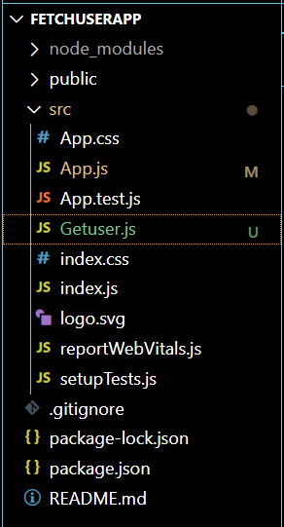

CODE:
App.js
import React from 'react';
import Getuser from './Getuser';

function App() {
return (
<div className="App">
<h1>User Info from Random API</h1>
<Getuser />
</div>
);
}

export default App;

Getuser.js
import React from 'react';

class Getuser extends React.Component {
constructor(props) {
super(props);
this.state = {
person: {},
loading: true,
};
}

async componentDidMount() {
const url = "https://api.randomuser.me/";
const response = await fetch(url);
const data = await response.json();
this.setState({ person: data.results[0], loading: false });
console.log(data.results[0]);
}

render() {
const { loading, person } = this.state;

if (loading) {
return <div>Loading...</div>;
}

return (
<div style={styles.container}>
<h2>{person.name.title} {person.name.first}</h2>
<img src={person.picture.large} alt="User" style={styles.image} />
</div>
);
}
}

const styles = {
container: {
border: '2px solid #ccc',
padding: '20px',
marginTop: '20px',
textAlign: 'center',
borderRadius: '10px',
width: '300px',
margin: 'auto'
},
image: {
width: '150px',
borderRadius: '50%',
marginTop: '10px'
}
};

export default Getuser;

OUTPUT:
